UNIT – 2

NETWORK INFRASTRUCTURE FOR E-COMMERCE

**What is the Internet?**

The [Internet](https://www.javatpoint.com/internet) is a global network that uses [TCP / IP](https://www.javatpoint.com/computer-network-tcp-ip-model) protocols to connect millions of computers worldwide. It can include different networks, such as private, public, organizational, academic, government, etc. It allows users to communicate with each other and share massive amounts of data in various formats. Internet is available in both modes, wired and wireless. In wired mode, the data travels through fiber optic cables, whereas in wireless mode, the data travels through radio waves.

## What is Intranet?

An [Intranet](https://www.javatpoint.com/intranet) is a part of the Internet and is owned and used privately by an organization. It is mainly used to connect all the computers and establish a private network of an organization to provide employees the ability to collaborate on projects, manage or update information, share calendars, and to-do list, etc. Organizations prefer using Intranet to keep their data inaccessible from outsiders, making their suspicious data and project information secure. Intranet includes a firewall to prevent unauthorized users from accessing the network.

**What is the issues of e-commerce?**

Lack of Personal Interaction: Customers may miss the personalized experience of shopping in person and interacting with sales associates.

Security Threats: E-commerce platforms are vulnerable to security threats, such as data breaches, hacking, and fraud, which can compromise customer data and harm businesses.

****Issues:****   
E-commerce, or electronic commerce, is the buying and selling of goods and services over the internet. While e-commerce has become increasingly popular and convenient for consumers and businesses alike, it also comes with several issues and challenges that must be addressed to ensure its success. Here are some of the most common e-commerce issues:

**[Privacy violation](https://www.geeksforgeeks.org/ethical-issues-in-information-technology-it/)–**

* Many times we heard that companies have sold the personal details of their customers.
* This is a very common issue nowadays even sometimes we allow sites to fully access our devices, and also when we fill personal details in our account section these details can be used for many purposes.
* E-commerce also keeps track of our online activity or product preferences and product listing based on this information they recommend products to us and advertise on platforms which we use like Facebook, Instagram, and many more.
* privacy invasion can also be done when there is low security in the e-commerce site. hackers can hack the servers of e-commerce sites and gets personal information of users like credit card details, phone number, and passwords.

**[Website spoofing](https://www.geeksforgeeks.org/ip-spoofing/) –**

* It is a technique to create the same lookalike website as other websites. When the user by mistake types any other word in place of the original word they land on a page that is the same as the original website.
* when a link is circulated among a group of persons of the fake website they basically contain malicious code or they lure customers to buy their product and give their personal details.

**Online piracy–**

It is unauthorized copyright of the original property. Many sites provide free copyright e-books, e-music, e-movies which are unethical.

Sometimes original trademarks are used to sell fake products. It is basically the use of other’s content without their permission or without any right to download and distribute it. It has become the most dangerous threat to content owners.

**[Email-spamming](https://www.geeksforgeeks.org/types-of-email-attacks/) –**

* Email spamming is a very common way to defraud users. This technique is also known as phishing. In this, spammers sent emails to customers and lure them with products and exciting offers.
* They tempt users to purchase their products and give their personal details on their fake websites.
* Sometimes these emails are marked as spam mails but most often when we give personal details such as name, email, phone number then they can easily send their mails to defraud users. It is also known as junk mails.

**Fraud:**

* E-commerce is vulnerable to fraud. Fraudsters may use stolen credit card information to make purchases or create fake websites to deceive customers into sharing their personal and financial information.
* Online businesses must be vigilant in detecting and preventing fraud, such as implementing security measures like two-factor authentication.

**Privacy:**

* Privacy concerns are another issue in e-commerce. Customers may be hesitant to share their personal information, such as their name, address, and email, with online businesses.
* Companies must be transparent in their data collection and use policies and provide customers with clear options for opting out of data collection.

**Shipping and delivery:**

* Shipping and delivery can be a major issue in e-commerce.
* Customers expect timely and reliable delivery of their purchases, and online businesses must have efficient logistics systems in place to meet those expectations.
* Unexpected delays, lost shipments, or damaged goods can lead to dissatisfied customers.

**Customer service:**

* E-commerce companies must provide high-quality customer service to retain customers and build a positive reputation. Customers expect prompt responses to their inquiries and concerns and easy returns and exchanges if necessary.
* Online businesses must have efficient customer support systems in place to address customer issues.

**Competition:**

* E-commerce is a highly competitive industry, and online businesses must differentiate themselves from their competitors to succeed.
* They must offer unique products, excellent customer service, and attractive prices to stay ahead of the competition.

**What are the problems of e-commerce in India?**

**We, therefore, enumerate the major challenges e-commerce in small enterprises is facing and also submit the remedial measures to meet these challenges.**

* Infrastructural Problems: ...
* Absence of Cyber Laws: ...
* Privacy and Security Concern: ...
* Payment and Tax Related Issues: ...
* Digital Illiteracy and Consumer Psyche: ...
* Virus Problem:

**The Network Infrastructure for E-Commerce**

I**ntroduction:**

• E-commerce needs a standard network infrastructure to transport the content.

• Internet and intranet are the basic tools to implement e-commerce. The network infrastructure is provided by I-way or business super highway.

• The information super highway may be defined as a high-capacity electronic pipeline that is capable of simultaneously supporting a large number of e-commerce applications and provide interactive phone like connectivity between users and services and among users.

• The ability to translate the content (media) into digital form is fundamental to all the changes associated with the I-way.

• Digitization refers to the process by which all media video, audio, text, graphics are processed by computers: manipulated, mixed, transform and delivered in new way.

**Information Super Highway (I-Way):**

• Electronic commerce needs a network infrastructure to transport the content-text, audio, video, graphics etc.

• The network infrastructure that provides such a data transmission facility is called I-Way or information super highway.

• Thus, information super highways can be defined as the high capacity, electronic and interactive pipeline to the consumer or business premise that is capable of supporting large number of ecommerce applications simultaneously

. • It is called interactive because it provides two-way communication between users and service providers or between one user and another user.

• It is called high-capacity electronic pipeline because it must provide broadband link.

• Historically, the voice and data networks have evolved separately, with voice networks relying on circuit switching and data networks using packet switching techniques.

• Thus, a business user requiring voice, data, and video conferencing services often had to use three separate networks- a voice network, a data network, and a videoconferencing network

. • I-way provides integration solution to the shortcoming of the need to have separate network for voice, data and video services respectively.

• Nowadays information super high way is emerged as basic network infrastructure for all

**Circuit Switching vs. Packet Switching**

• When two nodes communicate with each other over a dedicated communication path, it is called circuit switching.

• There is a need of pre-specified route from which data will travels and no other data is permitted.

• In circuit switching, to transfer the data, circuit must be established so that the data transfer can take place.

• Applications which use circuit switching may have to go through three phases: Establish a circuit, Transfer the data, Disconnect the circuit.

• Circuit switching was designed for voice applications. Telephone is the best suitable example of circuit switching. Before a user can make a call, a virtual path between caller and callee is established over the network.

**Broadband Connections:**

• A narrowband network is one that provides a single channel for communications across the physical medium.

• Broadband refers to the ability to stack frequencies on a single transmission medium, providing multiple channels on the same wire.

• Broadband technologies transmit multiple channels from same carrier by multiplexing the channels.

Time-Division Multiplexing (TDM) is the division of common transmission facility into two or more channels, one at a time. Each connection occupies a portion of time in the link.

• TDM is a method in which time slots on a shared transmission line are assigned to devices and the devices can only transmit data in the assigned time slots only.

**Components of the I-Way:**

• Various components contained in I-way can be broadly divided into three categories: Consumer access equipment, Access Roads or Media, and Global Information distribution network.

**Consumer Access Equipments:**

• These are the devices at consumer end and enables consumers to access the network. It consists of hardware and software.

• Hardware component includes devices such as computers, modems, routers, switches etc. for computer networks, set-top boxes, TV signal descramblers etc. for television networks, Cell phones etc. for cellular networks and so on.

• And software systems installed in those hardware devices includes browsers, operating systems etc.

• The type of consumer access equipment used depends upon the communication mode used. These equipments are also called customer premise equipments or terminal equipments. Access Roads/Media (Local on Ramps)

• These are the network infrastructure that provides linkage between businesses, homes, and schools to global information distribution network. This component is often called the last mile in telecommunication industry.

• Access road providers can be divided into four categories: Telecom based, Cable TV based, Wireless based, and Computer based online systems

. • Main function of access roads is to connect consumers with e-commerce applications. Telecom Based Access Roads

• Telecom industries provides high speed electronic pipeline which is capable for carrying large volume of audio, video, and text data.

Internet as a Network Infrastructure

• The Internet is a meta-network, that is, a network of networks that spans the globe. It is impossible to give an exact count of the number of networks or users that comprise the Internet, but it is easily in the thousands and millions respectively.

• The Internet employ once of standardized protocols which allow for the sharing of resources among different kinds computers that communicate with each other on the network.

• These standards are sometimes referred to as the Internet Protocol Suite.

• Packet switching technique is employed by Internet to transmit messages from one location to another location which makes high utilization network resources.

• This is the reason behind low cost of internet The Internet is a distributed system. There is no central store.

• Technically, no one runs the Internet. Rather, the Internet is made up of thousands of smaller networks

. • However, our connection to the Internet is probably controlled by an Internet Service Provider (ISP).

• People and organizations connect into the Internet so they can access its massive store of shared information. The Internet is an inherently participative medium. Anybody can publish information or create new services.

• A computer connected to the Internet is commonly referred to as a host. Connections are made using telephone lines, cable data lines, fiber optic, or even wireless signals.

• The data passed back and forth between host computers using packets and protocols

. • Internet use client/server model of communication. We (client) make request in the internet by using web browser. Some computer in the internet (server) makes resources requested by us and responds to our request by using software called web server.

**NETWORK ACCESS EQUIPMENTS**

1.HUB

A hub, at the most basic level, is a **“dumb” device that operates at the Physical layer of the OSI model**. A hub forwards **all signals it receives to all connected network devices**. Think of a hub as a “drunk” – when he speaks, he speaks to all around him, even if he really only means to speak with one person.

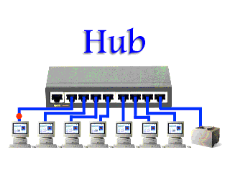

**2. Switch**:

Sometimes Hub can be an inefficient (think about the excess traffic created) and unsecure device. Imagine if you wish to send sensitive credit card information over the network – do you really want every node to receive your electronic signal? To alleviate this, the switch was developed. A switch **operates at the Data Link layer of the OSI model**. It uses the MAC sub-layer to **forward the relevant frames of information only to the intended recipient**. Messages can still be broadcast, but this is only an option and not the normal condition. Unlike the “drunken” hub, the switch can speak softly to one person at a time or announce to the crowd. The Network+ exam tends to test you on this **difference between a hub and switch**, so keep it fresh in your mind.

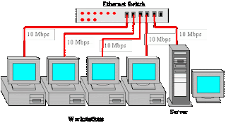

**3. Bridge**:

[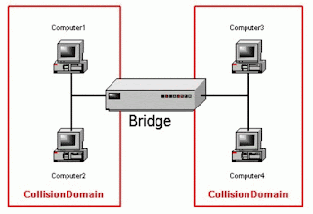](https://4.bp.blogspot.com/-rLy_7lb-2sQ/VUxJdfjZD6I/AAAAAAAAALA/-0aaIN_MVro/s1600/bridge.gif)

A *bridge* also operates at the Data Link layer (aka Layer 2) and is used to **connect two (similar or dissimilar) physical network segments together**, forming a larger inter-network. It can forward packets or reject them based on their destination (MAC) address.  Note: The connected network segments must have same network ID.

**4. Router**:

[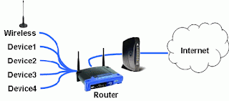](https://2.bp.blogspot.com/-InUkszLK4SE/VUxJhRJJrVI/AAAAAAAAALQ/JyAZqhkKd50/s1600/router.gif)

The *router* operates at the Network layer of the OSI Model and is used to **forward packets across network segments to reach a certain destination address**. Do not be confused between a router and a bridge – a bridge simply forwards packets or frames based on their destination address from one connected network segment to another. A router **can determine where a packet should be sent to given its final destination (IP address)**. Usually, routers forward packets to other routers, but sometimes routers also forward to other pieces of network equipment. A router is usually used to connect a home computer to an “always-on” Internet connection through the home network. To appreciate what a router really does, run tracert to your favorite website and see how many steps (hops) are involved in getting from your computer to the web server in question.

**5. Gateway**:

[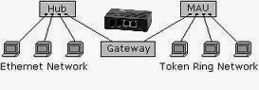](https://3.bp.blogspot.com/-nrSKDIrgkBE/VUxJdGTga2I/AAAAAAAAAK4/MPZI2I9cdiw/s1600/gateway.jpg)

A *gateway* is any device that serves to **interface with other networks using dissimilar protocols** . For example, a gateway might interface between a home network and the Internet or between a NetBIOS network and an IPX/SPX network. A gateway operates in any of the seven OSI layers.

**6. WAP**:

[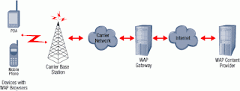](https://4.bp.blogspot.com/-mYGjbLhUUyE/VUxJinA-zoI/AAAAAAAAALg/km1ClAE31Hg/s1600/wap.gif)

A *Wireless Access Point* is a device that **allows wireless devices to access and to communicate with the network**. It acts as a **bridge between the wired, traditional network and other wireless devices***.*Alternatively, it can act as a bridge between wireless devices and another, linked WAP. It typically operates in the Network layer of the OSI model as a sort of router/bridge/switch combination. Note that most WAP devices direct traffic by MAC address, making them switched.

**7. NIC**:

[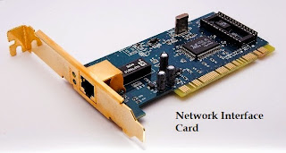](https://2.bp.blogspot.com/-qtcVu63paM8/VUxJdrCuOmI/AAAAAAAAAK8/Mn7GWUT6cE4/s1600/NIC.jpg)

A *Network Interface Card* is a device that allows **a node to connect to the network, typically in the form of a computer “card”** *(PCI/ISA)*, but also in the form of an external (think USB) device. It can either be wired and connect to a traditional, wired network, or wireless, and connect to a WAP.

# **What are Broadband Telecommunications?**

**[Broadband](https://www.easytechjunkie.com/what-is-broadband.htm)** **[telecommunications](https://www.smartcapitalmind.com/what-is-telecommunications.htm)** is any type of **[transmission](https://www.wikimotors.org/what-is-a-transmission.htm)** that makes use of a digital or **[analog signal](https://www.easytechjunkie.com/what-is-an-analog-signal.htm)** to relay voice and data. In most applications, the term is connected with systems that offer a rapid transmission of data, either using newer digital technology or an analog system that employs a wider **[bandwidth](https://www.easytechjunkie.com/what-is-bandwidth.htm)**. There are several different types of broadband telecommunications in common use today for both the workplace and the home.

One of the configurations that has been around for a number of years is the integrated services digital network, or ISDN. This network design can be used to relay voice and data over copper telephone lines. While not the fastest of broadband options, this telecommunications tool makes it possible to access the Internet without the need for a high-speed connection or a lot of resources.

Another common example of broadband telecommunications is the asynchronous transfer mode, referred to in the telecommunications world as ATM. Faster than ISDN, this option has proven to be extremely helpful for companies that rely heavily on the Internet and electronic communications. It is possible to establish this type of connection through a carrier, or the company can also install the equipment on site and manage their own ATM network with relative ease.

**ATM**

[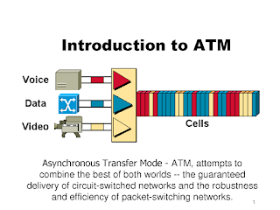](https://4.bp.blogspot.com/-Xo1x5ufmwYk/VUxQ_R4NruI/AAAAAAAAAME/gRBCsCTHPts/s1600/ATM.png)

* **Asynchronous Transfer Mode** (**ATM**) is, according to the ATM Forum, "a telecommunications concept defined by ANSI and ITU (formerly CCITT) standards for carriage of a complete range of user traffic, including voice, data, and video signals".
* ATM was developed to meet the needs of the Broadband Integrated Services Digital Network, as defined in the late 1980s,and designed to unify telecommunication and computer networks. It was designed for a network that must handle both traditional high-throughput data traffic (e.g., file transfers), and real-time, low-latency content such as voice and video.
* The reference model for ATM approximately maps to the three lowest layers of the ISO-OSI reference model: network layer, data link layer, and physical layer.
* ATM is a core protocol used over the SONET/SDH backbone of the public switched telephone network (PSTN) and Integrated Services Digital Network (ISDN), but its use is declining in favour of all IP.

**ISDN**

[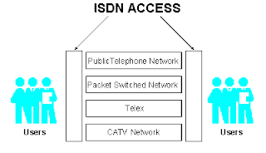](https://1.bp.blogspot.com/-SjZzzCgqz0U/VUxQ-eSLDCI/AAAAAAAAAL8/1l7LVI47oXE/s1600/isdn.gif)

* **Integrated Services for Digital Network** (**ISDN**) is a set of communication standards for simultaneous digital transmission of voice, video, data, and other network services over the traditional circuits of the public switched telephone network. Prior to ISDN, the telephone system was viewed as a way to transport voice, with some special services available for data.
* The key feature of ISDN is that it integrates speech and data on the same lines, adding features that were not available in the classic telephone system.
* *Integrated services* refers to ISDN's ability to deliver at minimum two simultaneous connections, in any combination of data, voice, video, and fax, over a single line. Multiple devices can be attached to the line, and used as needed.
* That means an ISDN line can take care of most people's complete communications needs (apart from broadband Internet access and entertainment television) at a much higher transmission rate, without forcing the purchase of multiple analog phone lines.
* It also refers to integrated switching and transmission in thattelephone switching and carrier wave transmission are integrated rather than separate as in earlier technology.

**Frame Relay**

[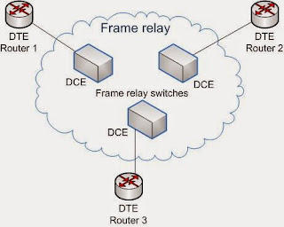](https://3.bp.blogspot.com/-x-GNgXmvywM/VUxQ-TxRSHI/AAAAAAAAAL4/DQ3HJ4cu6v0/s1600/Frame_relay.jpg)

**Frame relay** is a standardized wide area network technology that specifies the physical and logical link layers of digital telecommunications channels using a packet switching methodology. Originally designed for transport across Integrated Services Digital Network (ISDN) infrastructure, it may be used today in the context of many other network interfaces.

Network providers commonly implement frame relay for voice (VoFR) and data as an encapsulation technique, used betweenlocal area networks (LANs) over a wide area network (WAN). Each end-user gets a private line (or leased line) to a frame relaynode. The frame relay network handles the transmission over a frequently changing path transparent to all end-user extensively used WAN protocols. It is less expensive than leased lines and that is one reason for its popularity. The extreme simplicity of configuring user equipment in a frame relay network offers another reason for frame relay's popularity.

* The second popular home broadband telecommunications solution is the cable **[data network](https://www.easytechjunkie.com/what-is-a-data-network.htm)**.
* This approach makes it possible to enjoy some of the fastest voice and data communications possible, while also establishing a connection to a cable television provider.
* Many of these providers now use broadband to offer bundled services to customers that include home telephone service, Internet access, and cable television. In most designs, a single cable into the home establishes the network for all three functions.

The latest in broadband telecommunications is the wireless option. Systems of this type use a variety of different signaling solutions, including **[satellite](https://www.allthescience.org/what-is-a-satellite.htm)** and microwave transmissions to offer the high-speed connections for the transmission of voice and data.

Thanks to this solution, it is now possible for people to make telephone calls and access the Internet without the need for connection to equipment via a power cord.

As long as the handheld device or laptop computer is equipped with the right hardware and software to access the broadband network, it is possible to connect and enjoy speedy communications from anywhere in the area serviced by the wireless setup.

What is m-commerce?

M-commerce (mobile commerce) is the buying and selling of goods and services through wireless handheld devices such as smartphones and tablets. M-commerce is a form of e-commerce that enables users to access online shopping platforms without the use of a desktop computer.

# **Wireless Application Protocol (WAP) in Mobile Computing**

Wireless Application Protocol or WAP is a programming model or an application environment and set of communication protocols based on the concept of the [World Wide Web (WWW)](https://www.javatpoint.com/what-is-world-wide-web), and its hierarchical design is very much similar to TCP/IP protocol stack design. See the most prominent features of Wireless Application Protocol or WAP in Mobile Computing:

* WAP is a De-Facto standard or a protocol designed for micro-browsers, and it enables the mobile devices to interact, exchange and transmit information over the Internet.
* WAP is based upon the concept of the World Wide Web (WWW), and the backend functioning also remains similar to WWW, but it uses the markup language Wireless Markup Language (WML) to access the WAP services while WWW uses HTML as a markup language. WML is defined as XML 1.0 application.
* In 1998, some giant IT companies such as Ericson, Motorola, Nokia and Unwired Planet founded the WAP Forum to standardize the various wireless technologies via protocols.
* After developing the WAP model, it was accepted as a wireless protocol globally capable of working on multiple wireless technologies such as mobile, printers, pagers, etc.
* In 2002, by the joint efforts of the various members of the WAP Forum, it was merged with various other forums of the industry and formed an alliance known as Open Mobile Alliance (OMA).
* WAP was opted as a De-Facto standard because of its ability to create web applications for mobile devices.

## Working of Wireless Application Protocol or WAP Model

The following steps define the working of Wireless Application Protocol or WAP Model:

* The WAP model consists of 3 levels known as Client, Gateway and Origin Server.
* When a user opens the browser in his/her mobile device and selects a website that he/she wants to view, the mobile device sends the URL encoded request via a network to a WAP gateway using WAP protocol.
* The request he/she sends via mobile to WAP gateway is called as encoding request.
* The sent encoding request is translated through WAP gateway and then forwarded in the form of a conventional HTTP URL request over the Internet.
* When the request reaches a specified Web server, the server processes the request just as it would handle any other request and sends the response back to the mobile device through WAP gateway.
* Now, the WML file's final response can be seen in the browser of the mobile users.

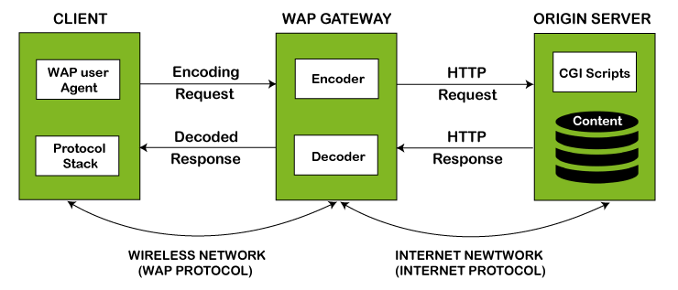

## WAP Protocol Stack

It specifies the different communications and data transmission layers used in the WAP model:

**[Application Layer](https://www.javatpoint.com/computer-network-application-layer):** This layer consists of the Wireless Application Environment (WAE), mobile device specifications, and content development programming languages, i.e., WML.

**[Session Layer](https://www.javatpoint.com/iot-session-layer-protocols):** The session layer consists of the Wireless Session Protocol (WSP). It is responsible for fast connection suspension and reconnection.

**Transaction Layer:** The transaction layer consists of Wireless Transaction Protocol (WTP) and runs on top of UDP (User Datagram Protocol). This layer is a part of TCP/IP and offers transaction support.

**Security Layer:** It contains Wireless Transaction Layer Security (WTLS) and responsible for data integrity, privacy and authentication during data transmission.

**Transport Layer:** This layer consists of Wireless Datagram Protocol (WDP). It provides a consistent data format to higher layers of the WAP protocol stack.

**Advantages of Wireless Application Protocol (WAP)**

Following is a list of some advantages of Wireless Application Protocol or WAP:

* WAP is a very fast-paced technology.
* It is an open-source technology and completely free of cost.
* It can be implemented on multiple platforms.
* It is independent of network standards.
* It provides higher controlling options.
* It is implemented near to Internet model.
* By using WAP, you can send/receive real-time data.
* Nowadays, most modern mobile phones and devices support WAP.

Disadvantages of Wireless Application Protocol (WAP)

Following is a list of some disadvantages of Wireless Application Protocol or WAP:

* The connection speed in WAP is slow, and there is limited availability also.
* In some areas, the ability to connect to the Internet is very sparse, and in some other areas, Internet access is entirely unavailable.
* It is less secured.
* WAP provides a small User interface (UI).

## **What Does Mobile E-Commerce Mean?**

## M-commerce (mobile commerce) is the buying and selling of goods and services through wireless handheld devices such as smartphones and tablets. M-commerce is a form of e-commerce that enables users to access online shopping platforms without the use of a desktop computer.

Mobile e-commerce (m-commerce) is a term that describes online sales transactions that use wireless electronic devices such as hand-held computers, mobile phones or laptops. These wireless devices interact with computer networks that have the ability to conduct online merchandise purchases. Any type of cash exchange is referred to as an e-commerce transaction. Mobile e-commerce is just one of the many subsets of electronic commerce.

## Mobile E-Commerce

The steady shift of consumer behavior to online shopping from retail stores hasn’t been lost on wireless electronic device manufacturers. Mobile electronic commerce is yet another way to purchase online items from electronic storefronts or online services from automated service providers. Computer-mediated networks enable these transaction processes through electronic store searches and electronic point-of-sale capabilities. Other mobile devices include dash-top mobile devices, personal digital assistants or smartphones.

One of the features of m-commerce sites is the adaptation of websites to make them easier to use with smaller screen sizes. There are a number of adaptations that can be made including the removal of large graphics and the optimization of fonts for easier viewing and ergonomics.